**OOAD ASSIGNEMENT PART A : CSE24-012. TADIWANASHE JEDIDIAH MUSIKAVANHU**

**1. Requirements Elicitation Session Record**

**Project Title:** Banking System – OOAD with Java  
**Module:** CSE202 – Object-Oriented Analysis & Design with Java  
**Date:** 18 Sept-25  
**Time:** 11:30  
**Place:** MS Teams  
**Interviewer (Analyst/Student):** Tadiwanashe Jedidiah Musikavanhu  
**Interviewee (Client/Stakeholder):** Kentsenao Baseki

**Interview Transcript (Q&A)**

**Functional Requirements:**

**Q1.** **Can you describe the different types of accounts?  
A1.** Individual and company accounts

**Q2.** **Should the system generate any reports?  
A2.** The system should not generate any reports, lets see if our model is correctly represented

**Q3.** **Are there any age or eligibility requirements for customers opening certain accounts?**

**A3**. Look on focusing on the OO of the project the rest are farfetched ideas.

**Q4.Do you require daily transaction limits for deposits or withdrawals?**

**A4.** Can dictate the currency and limit upon deposits/withdrawals. If it’s a display of the objects used in the design. Must match up with the design and data types. Class structure determines the data elements and types

**Q5. Should failed transactions (e.g., insufficient funds) be logged and displayed to the customer?**

**A5.** must give an alert message. Doesn’t have to record anything. There must be a transaction history

**Non-Functional Requirements:**

**Q6. Further explain in terms of usability:**

**A6.** Must represent current technology, current user expansion on technology, the design of the elements. Not only grey. Add color for each formation, not just plain things.

**2. Structural UML Modelling**

**2.1 Use Case Diagram.**

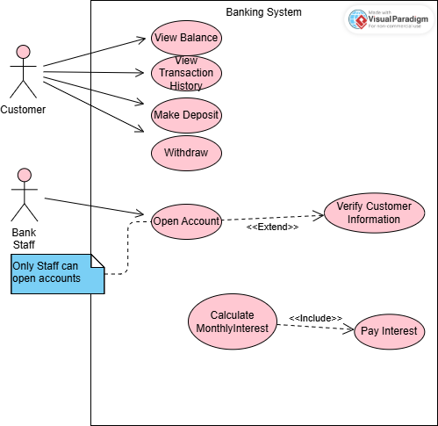

**2.2 Class Diagram.**

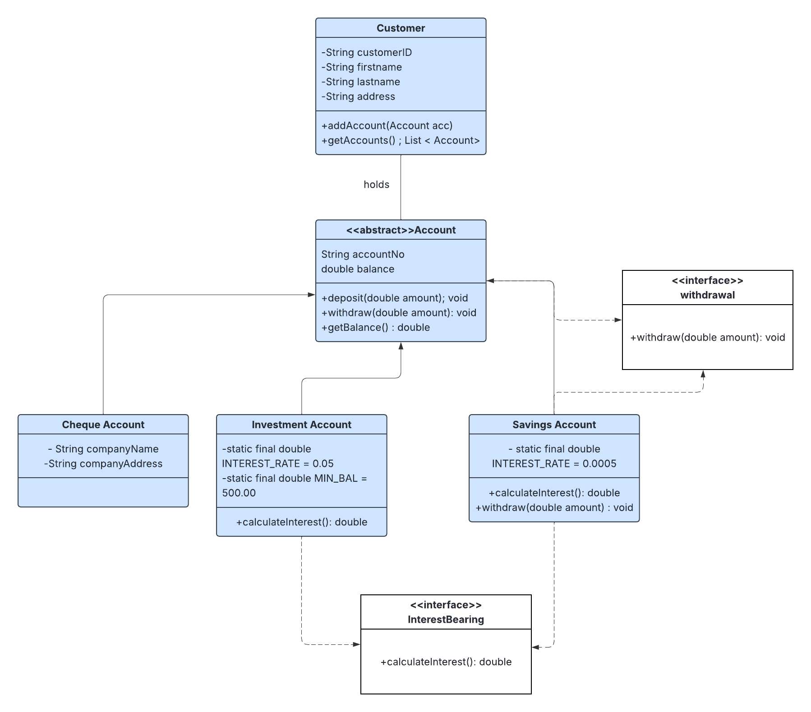

**3. Behavioural Modelling**

**3.1. Sequence Diagram**

**1. Deposit Sequence**

**Login Sequence**

**State Diagram\**

